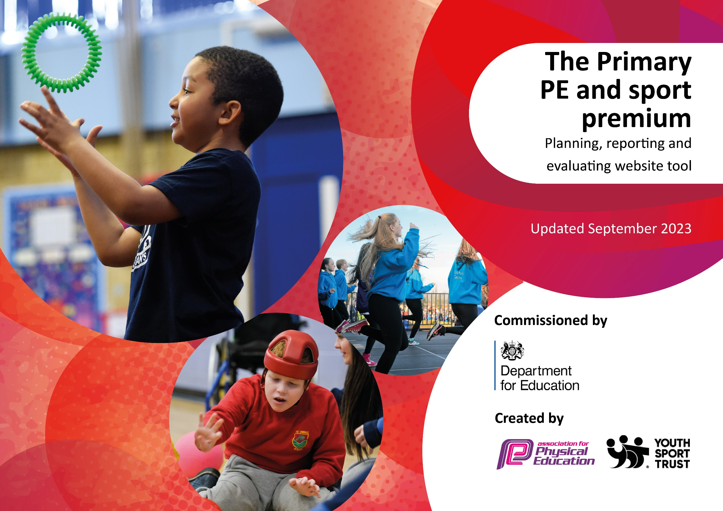

Review of last year’s spend and key achievements (2024/2025)

We recommend you start by reflecting on the impact of current provision and reviewing your previous spend.

Activity/Action | Impact | Comments
Internal evaluation form completed.
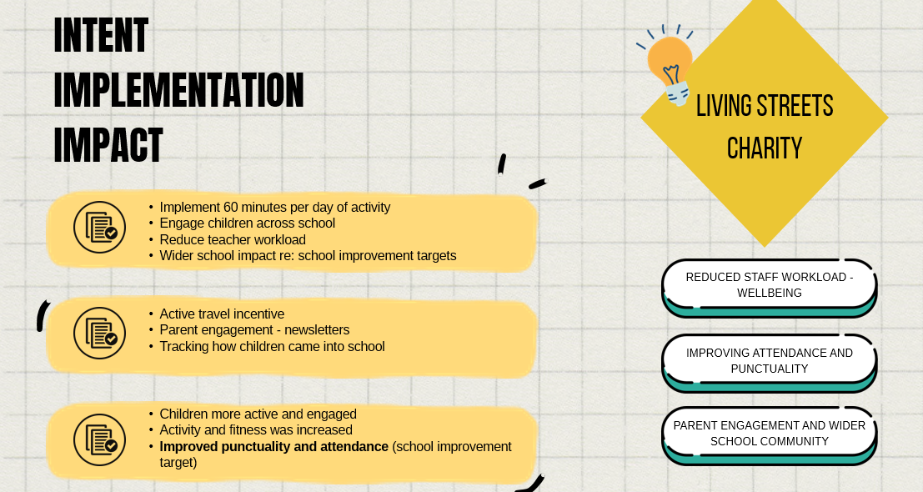
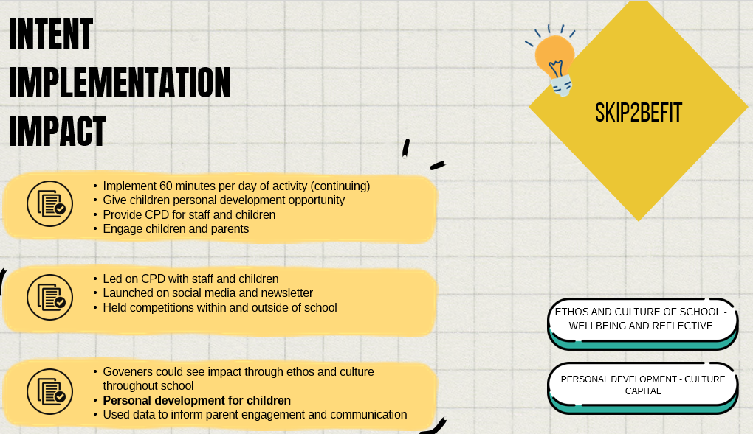
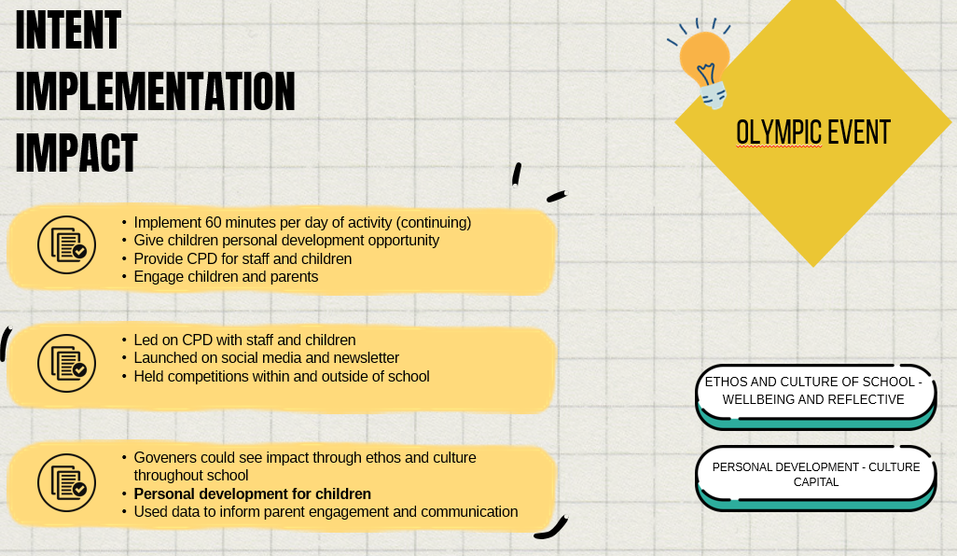

Key priorities and Planning
This planning template will allow schools to accurately plan their spending.

Action – what are you planning to do | Who does this action impact? | Key indicator to meet | Impacts and how sustainability will be achieved? | Cost linked to the action
Continuing to engage children in regular physical activity both in school and after school.  Continue to promote the benefits of an active lifestyle.  Extending the opportunity for activity across all areas of the playground.  Purchasing of new equipment for P.E lessons – Beanbags, Bibs, Javelin whistlers | Lunchtime supervisors / teaching staff, coaches - as they need to lead the activity  Pupils – as they will take part. | Key indicator 2 -The engagement of all pupils in regular physical activity – the Chief Medical Officer guidelines recommend that all children and young people aged 5 to 18 engage in at least 60 minutes of physical activity per day, of which 30 minutes should be in school.  Key indicator 4: Broader experience of a range of sports and activities offered to all pupils.  Key indicator 3: The profile of PE and sport is raised across the school as a tool for whole school improvement | P.E. lessons are now fully resourced which enables all pupils to access high-quality sporting opportunities across all Key Stages within the school.  This has led to more children being active for a longer period of time in their P.E Lessons and teachers being able to deliver sessions which promote the benefits of an active lifestyle and engage children in regular exercise. | School Council recently purchased new lunchtime equipment for playground.  Bean bags  https://shop.wf-education.com/sports/cotton-bean-bags.html  Pack of 40  £24.10  Bibs  https://shop.wf-education.com/sports/central-mesh-training-bibs.html  Pack of 12  £21.00
Children to be offered a range of sporting activities in order to broaden their experiences their experiences and develop their cultural capital throughout the year. This could be through sports clubs and through their school sports competitions.  Continue to offer a range of sports clubs to children encompassing different sports. Clubs will be run on a rota basis and will allow each year group to have access to 6 clubs a year. | Coaches/P.E Lead – Organising and running clubs and tracking attainment through the clubs.  Pupils – Attending the clubs. | Key indicator 2 -The engagement of all pupils in regular physical activity – the Chief Medical Officer guidelines recommend that all children and young people aged 5 to 18 engage in at least 60 minutes of physical activity per day, of which 30 minutes should be in school.  Key indicator 4: Broader experience of a range of sports and activities offered to all pupils.  Key indicator 3: The profile of PE and sport is raised across the school as a tool for whole school improvement  Key indicator 5: Increased participation in competitive sport | Premier Education provide six after-school clubs per week.  Autumn 1  Year 1 – Gymnastics and Knights and Castles  Year 2 - Gymnastics and Knights and Castles  Year 3 - Gymnastics and Quidditch  Autumn 2 based on pupil voice from last year  Year 4, 5 and 6 all did Dodgeball and Basketball  Spring 1  Multi Sports, Dodgeball, Volleyball and Hockey  Spring 2  Archery, Netball and Gymnastics.  Mixed Year 4,5,6 Gymnastics Club  Summer 1  Year 1  Athletics  Multi Sports  Year 2  Athletics  Multi Sports  Year 3  Football  Tri-Golf  Summer 2  Year 6  Football and Tennis  Year 5  Football/Rounders  Year 4  Football  Cricket  After-school club data report:  Autumn 1:  Total children attended - 410  Girls - 228 - 55.6%  Boys - 182 - 44.4%  Autumn 2:  Total children attended - 317 (half term to date 5th Dec)  Girls - 137 - 43.2%  Boys - 180 - 56.8%  Spring 1 after school data:  Number is lower due to 5 clubs running per week.  Total attendees: 349  Girls: 136  Boys: 213  Spring 2 after school club:  Total children attended to date.  Total attendees: 324  Girls: 175  Boys: 149  Summer 1 (4 week term)  Total children attended – 215  Girls –121– 56%  Boys – 94 – 44%  Staffordshire Cricket Club are came into school to lead a six week program of workshops with four classes. They also ran a lunchtime club and an after school club as part of their efforts to increase engagement with children in Cricket.  Sessions with Premier Education in association with the Tennis Lawn Association were very successful. Year 4 and one Year 5 class benefitted from the sessions with coaches. The children got to think more about the skills needed in Net and Wall games and were able to make links to skills used in other sports. Tennis Lawn Association resources were also shared with the school to allow for CPD to be delivered to staff to ensure that practice is sustainable. | Lunchtime Coaching sessions  £8910  After school club costs  £10692  (A proportion of this is to be supplemented from Pupil Premium budget)
Renewal of Get set 4 P.E. Scheme. Roll this out across school by delivering training to all staff. High quality teaching needs to be consistent and evident from all class teachers that teach P.E. It needs to be clear to staff how content can be adapted for all and have the confidence to make these judgements to get the best out of their children in sessions. New staff will be given training on all aspects of P.E at Pennyhill. | Teachers – planning and delivery of lessons.  Pupils – will engage in activities during the P.E lessons. | Key indicator 1: Increased confidence, knowledge and skills of all staff in teaching PE and sport  Key indicator 2: Engagement of all pupils in regular physical activity  Key indicator 4: Broader experience of a range of sports and activities offered to all pupils | Getset4P.E. is now the heart of our P.E provision.  It supplies teachers with CPD for each lesson they teach and clear, well designed lesson plans to follow.  Getset4P.E. is also where we assess children on their P.E. It provides teachers with easy to follow success criteria’s for each unit taught to aid them in making accurate and effective judgements regarding their children’s attainment.  Children and staff have a better understanding of Physical Literacy.  Teachers are continuing to teach high quality lessons.  Teachers report that their own subject knowledge has improved since using Getset4PE.  Children are given a broad curriculum allowing them to focus on developing their Physical literacy as the scheme has the whole child at its core.  Assessment in P.E. is now evident in all year groups and teachers have clear guidance on how to assess their children in each area of P.E.  Staff are consistently using the assessment objectives to inform lesson outcomes and teachers are updating tracker promptly after each unit. | £495 for one year renewal
Showcasing the importance of sport and a healthy lifestyle will be evident in our school’s culture.  High quality PESSPA provision will be evident at all times across school. Continue to develop children’s engagement in activities and develop their knowledge of P.E skills.  Continue to work with Living Streets Charity to support the promotion of walking to school. | Whole school community. | Key indicator 2: Engagement of all pupils in regular physical activity  Key indicator 4: Broader experience of a range of sports and activities offered to all pupils  Key indicator 3: The profile of PE and sport is raised across the school as a tool for whole school improvement.  Key indicator 5: Increased participation in competitive sport. | Timetable constraints mean that achieving 60 active minutes daily in school is a challenge. This initiative allows us to track active minutes prior to the school day starting and allows us to promote an active lifestyle beyond our school grounds. We are now in our third year of partnership with Living Streets Charity and we are continuing to promote active travel to school. | Living streets partnership has no cost as funding has come from Sandwell Council
All children to be given multiple opportunities to compete within school and against other schools.  Children will have the ability to represent their class, their House, and to represent Pennyhill. They will have a chance to proudly represent the school, and themselves, in the local community.  After each P.E unit, an intra-school competition will be held. | Teachers – Recording skipping/travel tracker daily. Completing inter house competitions at the end of each P.E unit.  P.E Lead – track data and facilitate opportunities for competition,  Pupils – Show good sportsmanship and compete with pride. | Key indicator 2: Engagement of all pupils in regular physical activity  Key indicator 4: Broader experience of a range of sports and activities offered to all pupils  Key indicator 3: The profile of PE and sport is raised across the school as a tool for whole school improvement.  Key indicator 5: Increased participation in competitive sport. | The profile of P.E. across our school has been steadily increasing over the course of the last three years. Parents are updated on school newsletters regarding current sporting activities in school and our school Sports Day continues to be a large event in our school calendar. This provides children with the opportunity to compete for their houses and showcase their talents to parents and wider school community.  Children are given opportunites in and out of P.E. lessons to compete against themselves and others in various sporting events. They also have the opportunity to personally develop through the Skip2beFit program.  The impact of these initiatives has been seen in the number of children engaging in competitive sport and the profile of sport being raised across the school. | Cost of Coaches and staff

Introduce a whole school skipping program to increase activity levels of children and give children opportunities for personal development. This initiative will replace the daily mile and will also provide opportunities for competition. | Teachers – To complete weekly 2 minute skipping challenges. Tracking children’s progress.  Pupils – Will be engaging in the program. | Key indicator 2: Engagement of all pupils in regular physical activity  Key indicator 4: Broader experience of a range of sports and activities offered to all pupils  Key indicator 3: The profile of PE and sport is raised across the school as a tool for whole school improvement.  Key indicator 5: Increased participation in competitive sport.  Key indicator 1: Increased confidence, knowledge and skills of all staff in teaching PE and sport | Skip2befit is a skipping programme we brought into last year to promote an active lifestyle, provide a personal development opportunity for the children and encourage 60 active minutes. This initiative was intended to replace the ‘Daily Mile’ by giving children regular opportunities to exercise.  KS1 focus on basic skipping skills whereas KS2 track the number of skips completed in a 2 minute period. This enables us to monitor fitness levels within our children whilst also providing the children with a fun energetic way to exercise. Last year, all children were given a skipping rope to keep in school so they can practice skipping at break time and lunchtime. This also contributes to having an active lunchtime.  8/12 classes have improved their total number of skips over the half term.  Where classes have not shown improvement it is seen that the programme is not being consistently accessed by the children.  The average number of skips in KS2 went from 2380 in 2 minutes to 2519 in two minutes.  4A’s class total has gone from 3391 skips per 2 minutes to 4269 skips in 2 minutes.  5E’s class total has gone from 3287 skips per 2 minutes to 4851 skips in 2 minutes.  5R’s class total has gone from 4093 skips per 2 minutes to 4717 skips in 2 minutes.  5A’s class total has gone from 3799 skips per 2 minutes to 4667 skips in 2 minutes. | Skipping program carries no extra costs from last year.

Percentage of pupils in current Year 6 cohort that can swim competently, confidently and proficiently over a distance of 25m. | Percentage of pupils who can use a range of strokes effectively. | Perform safe self-rescue in different water-based situations
9% | 18% | 20%
Swimming Data 2024-25
Based on one terms worth of swimming provision due to alteration on provision allocation.

Signed off by:

Head Teacher: | E Williams
Subject Leader or the individual responsible for the Primary PE and sport premium: | Mr J Bridges
Governor: | J Padam
Date: | 29/08/2024

